LAVA: A Lightweight Benchmarking Framework for Robust and Efficient Deepfake Voice Detection
Quoc Hung NGUYEN ^{*[0000-0002-6363-0160]},
Khac Anh Tuan PHAN ^{[0009-0006-5164-465X]}, Thanh Dat LAI ^{[0009-0002-3962-960X]}
Tan Khiem NGUYEN ^{[0009-0003-2085-6252]}, Thanh Dat TRUONG ^{[0009-0006-6562-3956]}
University of Economics Ho Chi Minh City (UEH), Ho Chi Minh City, Viet Nam
Corresponding author: hungngq@ueh.edu.vn
Abstract. Deepfake voice detectors are difficult to compare across incompatible data partitions, score conventions, calibration, preprocessing, and timing. LAVA applies common artifact-integrity, P(FAKE), diagnostic-stress, and runtime contracts while preserving native computation. We evaluate four locally trained Mel-sequence artifacts and externally pretrained RawNet2 and AASIST reference artifacts, whose training and calibration provenance differs. SHA-256 grouping quarantined 30 cross-label files and produced a checksum-group-disjoint manifest; clean evaluation used all 2,737 test recordings. ShuffleNetV2 achieved the highest AUC (0.9929) and lowest EER (1.46%); its threshold-specific F1 was 0.9824. On one single-thread desktop CPU, MobileNetV3 had the lowest end-to-end latency (43.81 ms; RTF 0.0146), while ShuffleNetV2 required 62.52 ms (RTF 0.0208). A fixed stratified 100-recording diagnostic evaluated seeded AWGN, four codec round trips, and simulated replay. On this subset, low-SNR noise was the main observed weakness, and ShuffleNetV2 retained the highest mean stressed F1 (0.8133). Using diagnostic-subset EER, mean stressed F1, and end-to-end RTF, the exploratory analysis identifies MobileNetV3 and ShuffleNetV2 as non-dominated under the evaluated objectives. These findings support deployment-oriented offline comparison, but do not establish full-test robustness, unseen-corpus generalization, physical-replay robustness, streaming, edge-device performance, or multi-seed stability.
Keywords: Deepfake voice detection, audio anti-spoofing, lightweight deep learning, robustness, computational efficiency, Pareto analysis.
- Introduction
Synthetic and converted speech pose risks to speaker verification and human decision-making. Despite rapid progress in deepfake voice detection [1], [2] and shared evaluation resources such as ASVspoof and WaveFake [3], [4], comparisons remain difficult because studies differ in data partitions, label conventions, input duration, preprocessing, calibration, and runtime boundaries. Byte-identical recordings across data splits introduce an additional integrity concern.
LAVA compares heterogeneous deployed artifacts through one interface while preserving their Mel-sequence or raw-waveform pipelines. It standardizes integrity checks, P(FAKE) semantics, stress conditions, outputs, and timing. Four artifacts were trained locally; RawNet2 and AASIST are external references. Clean evaluation uses the full test set, stress diagnostics use a fixed subset, and timing uses one desktop CPU, so the evidence does not establish general robustness, streaming, or edge-device operation. The study addresses:
- RQ1: How do deployed artifacts compare on clean AUC and EER, and how should threshold-dependent metrics be interpreted under heterogeneous training and calibration?
- RQ2: How does absolute performance change under the executed noise, codec, and simulated-replay conditions on the fixed diagnostic subset?
- RQ3: Which artifacts are non-dominated across diagnostic-subset EER, mean stressed F1, and end-to-end RTF?
LAVA contributes: (1) checksum-group-disjoint, artifact-traceable clean evaluation centered on AUC/EER and provenance; (2) matched fixed-subset diagnostics for noise, compression, and simulated replay with aggregate failure-pattern analysis; and (3) desktop-CPU timing and exploratory three-objective Pareto analysis for scenario-specific recommendations.
- Related Work
  - Deepfake Voice Detection and Benchmark Protocols
ASVspoof 2019 separates logical-access synthesis and conversion from replay-oriented physical access [3], [5]; ASVspoof 2021 adds channel, compression, and real-environment replay variation [6]. WaveFake covers multiple generators and two languages [4] [7]. RawNet2, AASIST, wav2vec 2.0, and LCNN systems broaden the model and representation choices [8], [9], [10], [11], [12], but their scores remain tied to the corresponding datasets, attack partitions, preprocessing, and decision protocols.
  - Robustness Replay and Unseen Data Generalization
Robustness and generalization concern different shifts. ASVspoof 2019 uses controlled replay simulations, whereas the 2021 tasks add real-room replay, channel or compression effects, and unmatched evaluation data [6]. A wav2vec 2.0 system fine-tuned on 2019 logical-access data is tested on 2021 sets with unmatched codec, attack, and source-domain variation [11]. Cross-source studies evaluate a collected real-world corpus, attack-disjoint folds, or multiple deepfake datasets [13], [14], [15], [16], [17], while WaveFake's baselines focus mainly on training-like distributions [4]. These protocols are not interchangeable evidence for noise, codec, replay, or unseen-corpus performance.
  - Computational Efficiency and Deployment Oriented Evaluation
Deployment evidence requires a common workload and timing boundary. MobileNetV3, ShuffleNetV2, MnasNet, and EfficientNet report efficiency for vision workloads [18], [19], [20], [21], [22], [23] not complete audio pipelines. The surveyed anti-spoofing studies emphasize EER or t-DCF and generally omit end-to-end latency or RTF under one audio protocol [8], [10], [11]; model size alone is not a deployment proxy.
Table 1. Reported evaluation coverage in representative studies.
Study | Noise | Compression | Replay | Unseen Data | Latency/RTF | Edge
ASVspoof 2019 [3] | - | - | Yes | Yes | - | -
WaveFake [4] | - | - | - | Yes | - | -
ASVspoof 2021 [6] | - | Yes | Yes | Yes | - | -
RawNet2 [8] | - | - | - | Yes | - | -
AASIST [10] | - | - | - | Yes | - | -
wav2vec 2.0 aug. [11] | - | Yes | - | Yes | - | -
Pascu et al. [13] | - | - | - | Yes | - | -
Müller et al. [14] | - | - | - | Yes | - | -
Attack Agnostic [15] | - | - | - | Yes | - | -
LAVA (this work) | Yes | Yes | Yes | - | Yes | -
Note. Yes = evaluation results reported; - = not reported. Unseen Data requires a held-out attack, generator, corpus, or domain; augmentation alone does not qualify. Replay is simulated for ASVspoof 2019 and LAVA; ASVspoof 2021 PA uses real environments. Latency/RTF and Edge require measured audio-pipeline timing and target-hardware tests, respectively.
The surveyed studies assess clean discrimination, robustness or generalization, and efficiency under different protocols, making deployment-oriented comparison across heterogeneous artifacts difficult. LAVA applies one artifact-traceable offline contract to six available artifacts. It does not claim unseen-corpus generalization, physical-replay robustness, streaming, or edge-device validation.
- Methodology
  - LAVA Framework and Experimental Protocol
LAVA separates canonical data and integrity (D), registered detectors (M), conditions (C), measurements (E), and analyses (A). The registry records each artifact's input, duration, threshold, and provenance; adapters preserve native computation while exposing common scores and resource measures. Runners derive statistics and figures from stored sample-level outputs while distinguishing planned from executed conditions (Figures 1 and 2).

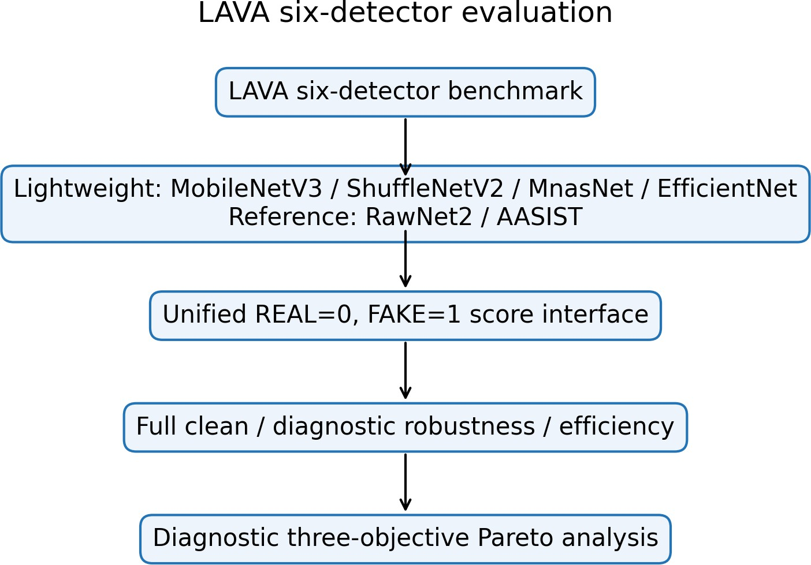
Fig. 1 . Six native detectors under the unified LAVA evaluation contract.
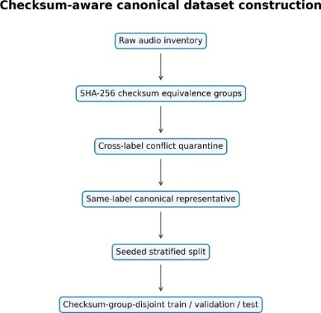
Fig. 2. SHA-256 conflict quarantine, canonical-ization, and disjoint splitting.

  - Dataset Integrity and Canonical Split
The internal collection lacks speaker, source, generator, parent-recording, and dataset identifiers, so the split cannot establish independence on those axes. LAVA scanned 18,722 files, found 435 duplicate groups and 476 redundant files, and quarantined 30 files in 14 cross-label checksum groups. The lexicographically first path represents each same-label group. The retained 18,232 recordings (10,493 REAL; 7,739 FAKE) were split with seed 42 into 12,762/2,733/2,737 train/validation/test files (Table 2). The supported property is checksum-group disjointness. For h(x) = SHA256(x) and split group sets Gs,
$$x_{i}∼x_{j}⇔h\left(x_{i}\right)=h\left(x_{j}\right), G_{tr}∩G_{va}=G_{tr}∩G_{te}=G_{va}∩G_{te}=∅.$$
The manifest hash is:
8b55591d58d3658b8cafe0e77b6ebdedbaa67be2e339730a7276fe9b10958df9.
Table 2. Canonical manifest and split inventory
Inventory | Count | Split | Count
Scanned / retained | 18,722 / 18,232 | Train | 12,762
Retained REAL / FAKE | 10,493 / 7,739 | Validation | 2,733
Duplicate groups / redundant | 435 / 476 | Test | 2,737
Cross-label groups / files | 14 / 30 | Split property | checksum-group-disjoint

  - Standardized Audio Preprocessing
Lightweight inputs are decoded, channel-averaged, polyphase-resampled to 22,050 Hz, and padded/truncated to 3.0 s. Six chronological 0.5-s segments use a Hann STFT (N = 2048, hop 512), 128 HTK-style Mel filters spanning 20–8,000 Hz, relative dB mapping clipped to 80 dB, [0, 255] scaling, bilinear 224 × 224 resizing, and RGB replication [24]. For segment t
$$X_{t}\left(m,k\right)=\sum_{n=0}^{N-1}{x_{t}}\left[n+mH\right]w\left[n\right]e^{-j2πkn/N}, S_{t}^{mel}\left(m,r\right)=\sum_{k}{{\left|X_{t}\left(m,k\right)\right|}^{2}}H_{r}\left(k\right)$$
  - Evaluated Detector Architectures
For the lightweight family, shared segment encoder fθ produces six embeddings, an LSTM with 128 units aggregates them, and a 64-unit ReLU layer plus dropout 0.4 feeds a sigmoid:
$$p_{fake}=σ\left(W_{2}{\text{Dropout}}_{.4}\left(\text{ReLU}\left(W_{1}\text{LSTM}\left(f_{θ}\left(X_{1:6}\right)\right)+b_{1}\right)\right)+b_{2}\right).$$
  - Training Artifact Provenance and Score Semantics
MobileNet and EfficientNet use ImageNet initialization; the available EfficientNet-B0 artifact is the best warm-up checkpoint, not a completed fine-tuning result. MnasNet and ShuffleNet were trained from scratch. RawNet2 and AASIST are externally pretrained reference artifacts and were not trained under the local protocol (Figure 3).

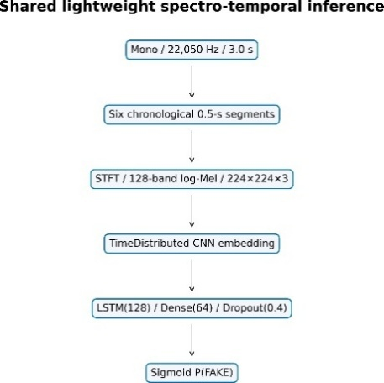
(a) Mel-sequence temporal path

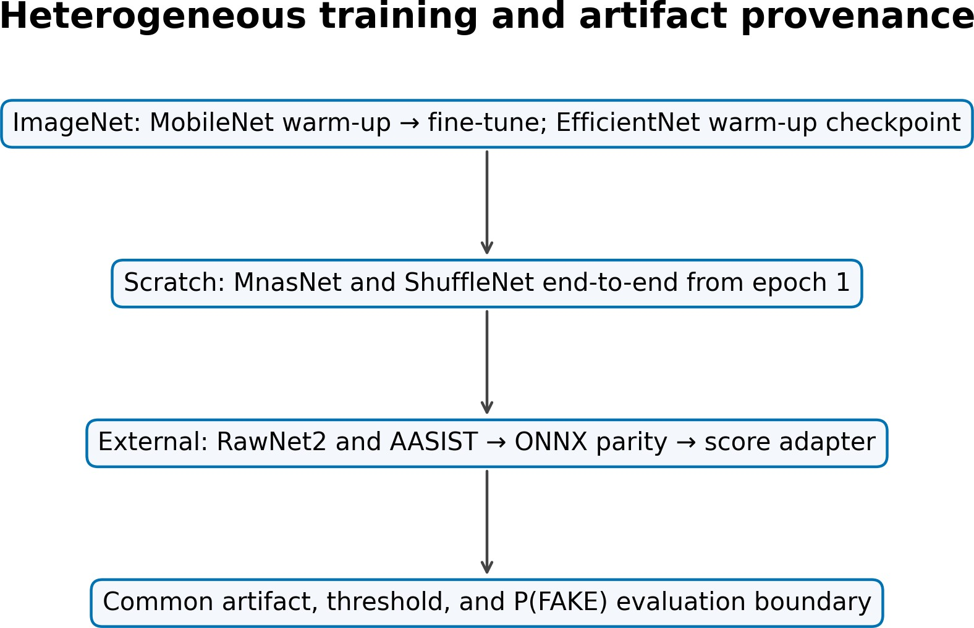
(b) Artifact provenance
Fig. 3. Architecture and provenance: the evaluation contract is shared, training is not.
Table 3. Detector specification, provenance, and deployed threshold
Detector | Input | Temporal core | Params | Initialization/artifact provenance | τ
MobileNetV3-LSTM [18] | Mel, 3.0 s | LSTM(128) | 1,308,401 | ImageNet; warm-up + partial fine-tune | .82
ShuffleNetV2-LSTM [19] | Mel, 3.0 s | LSTM(128) | 1,868,441 | scratch; full end-to-end, best epoch 16/28 | .12
MnasNet-A1-LSTM [22] | Mel, 3.0 s | LSTM(128) | 3,369,255 | scratch; full end-to-end, best epoch 27/39 | .90
EffNet-B0 warm-up [23] | Mel, 3.0 s | LSTM(128) | 4,779,300 | ImageNet; available warm-up epoch 47 | .90
RawNet2 [8] | waveform, 4.04 s | GRU | 17,621,410 | external reference; ONNX export | .50
AASIST [10] | waveform, 4.04 s | graph readout | 297,866 | external reference; ONNX export | .50
RawNet2 and AASIST were strictly loaded in PyTorch and exported to ONNX. Maximum native/export score differences were 4.11 × 10−6 and 5.96 × 10−8 on six real tensors. This verifies conversion, not equal training or publication-pipeline equivalence.
LAVA fixes REAL=0 and FAKE=1; every adapter returns p = P(FAKE) and applies the detector threshold listed in Table 3.
$$\overset{ˆ}{y}=1\left[p≥τ\right], τ^{*}=\arg{\max_{τ}{F}}1_{val}\left(τ\right).$$
The four lightweight thresholds in Table 3 are validation-only. The external reference artifacts use the uncalibrated default threshold of 0.5. Labels do not influence threshold selection or weighting, and scores are not interpreted as calibrated real-world probabilities.
  - Clean and Diagnostic Stress Evaluation
Clean evaluation uses all 2,737 test recordings (1,575 REAL, 1,162 FAKE). Accuracy, precision, recall, F1, macro-F1, ROC-AUC from raw scores, and linearly interpolated EER are reported. With FAKE positive,
$$P=\frac{TP}{TP+FP}, R=\frac{TP}{TP+FN}, F1=\frac{2PR}{P+R}; FAR=\frac{FP}{FP+TN},$$
$$FRR=\frac{FN}{FN+TP}, EER≃\frac{FAR+FRR}{2}.$$
Diagnostic stress evaluation uses a fixed 100-recording subset (58 REAL, 42 FAKE; seed 42), and every artifact uses the same recordings. Four seeded AWGN levels (20, 10, 5, 0 dB) use sample-identity-derived seeds. FFmpeg round trips cover MP3 128/64 kb/s, Opus 64 kb/s, and AAC 96 kb/s. Simulated replay applies taps at 0/17/43/89 ms with gains 1/.45/.25/.12, normalization by 1.82, and a causal fourth-order 100-3,800-Hz band-pass; it is not physical replay. For nine conditions,
$$Δ{F1}_{k}={F1}_{clean}-{F1}_{k}, {\overline{F1}}_{stress}=\frac{1}{9}\sum_{k=1}^{9}{{F1}_{k}}.$$
Negative degradation denotes improvement relative to a low diagnostic-subset baseline and is not evidence of general robustness. Full-test stress evaluation was not run; physical replay and unseen-corpus evaluations are not available.
  - Computational Efficiency Evaluation
Each artifact runs float32, batch one, one backend thread, and no accelerator in an isolated process. Ten warm-ups precede 50 timed runs. Measures include model-only and end-to-end latency, P95, load time, throughput, and whole-process RSS. The host is an AMD Ryzen 9 8940HX with 15.28 GiB usable RAM on 64-bit Windows 11 Pro build 26200; TensorFlow 2.15 and ONNX Runtime 1.17.3 execute the local and external artifacts, respectively. For N clips,
$$Q=\frac{N}{T_{total}}, RTF=\frac{T_{processing}}{T_{audio}}.$$
An RTF below one indicates faster-than-duration offline processing on this host; it does not establish causal streaming or edge-device deployment.
The exploratory Pareto analysis minimizes diagnostic-subset EER and end-to-end RTF while maximizing mean F1 across the nine executed stress conditions. After negating mean stressed F1, A dominates B when every objective is no worse and at least one is better:
$$g(m)=({EER}_{diag}(m),-{\overline{F1}}_{stress}(m),RTF(m)).$$
$$g_{i}(A)≤g_{i}(B) ∀i, and ∃j:g_{j}(A)<g_{j}(B).$$
Table 4. Clean performance on all 2,737 canonical test recordings. Accuracy, precision, re-call, F1, and macro-F1 use each artifact's deployed threshold; AUC and EER are threshold-independent.
Artifact | Accuracy | Precision | Recall | F1 | Macro-F1 | AUC | EER
MobileNetV3 | .9766 | .9741 | .9707 | .9724 | .9761 | .9911 | .0250
ShuffleNetV2 | .9850 | .9795 | .9854 | .9824 | .9847 | .9929 | .0146
MnasNet-A1 | .9697 | .9599 | .9690 | .9645 | .9690 | .9886 | .0310
EffNet-B0 warm-up | .9635 | .9724 | .9406 | .9563 | .9624 | .9877 | .0400
RawNet2 ext. | .4936 | .4380 | .6807 | .5330 | .4900 | .5178 | .4813
AASIST ext. | .5513 | .4758 | .5585 | .5139 | .5487 | .5597 | .4463

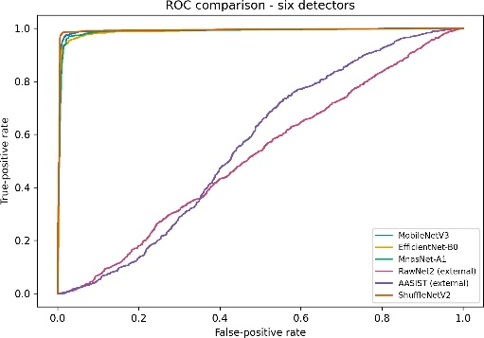
- ROC
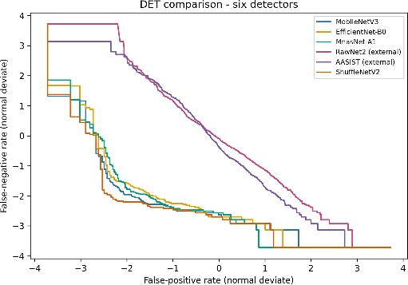
- DET/EER
Fig. 4. Threshold-independent clean discrimination on the full test split.
- Results and Discussion
  - RQ1 Clean Detection Performance
All artifacts passed load, score, hash, and adapter checks. On the full test set, ShuffleNetV2 had the highest AUC (0.9929) and lowest EER (0.0146), followed by MobileNetV3 (0.9911; 0.0250), MnasNet-A1, and the available EfficientNet-B0 warm-up checkpoint (Table 4 and Figure 4). RawNet2 and AASIST operated near chance under this dataset and adapter. Threshold-specific metrics use each deployed threshold.
This is not a controlled architecture study. Training data, initialization, duration, representation, loaders, and calibration differ across artifacts; the results neither rank the RawNet2 or AASIST architectures nor estimate retrained performance.
  - RQ2 Diagnostic Performance under Executed Distortions
On the fixed 100-recording diagnostic subset, AWGN caused the largest observed losses for the four high-performing lightweight artifacts. Mean noise ΔF1 ranged from 0.3555 for ShuffleNetV2 to 0.8053 for the available EfficientNet-B0 warm-up checkpoint and rose sharply at 5 and 0 dB. Table 5 and Figure 5 report the condition-level patterns.
Table 5. Fixed 100-recording diagnostic stress results. ΔF1 is clean minus stressed perfor-mance; replay is simulated.
Artifact | Clean F1 | Diagnostic EER | Noise ΔF1 | Codec ΔF1 | Sim. replay ΔF1 | Mean stressed F1
MobileNetV3 | .9756 | .0476 | .6722 | .0095 | .0620 | .6657
ShuffleNetV2 | .9756 | .0476 | .3555 | .0032 | .0256 | .8133
MnasNet-A1 | .9756 | .0476 | .6119 | .0233 | .1489 | .6767
EffNet-B0 warm-up | .9630 | .0476 | .8053 | .0000 | .0641 | .5980
RawNet2 ext. | .5660 | .4138 | .5077 | −.0007 | −.0109 | .3419
AASIST ext. | .5060 | .3810 | −.0660 | −.0074 | −.0682 | .5462

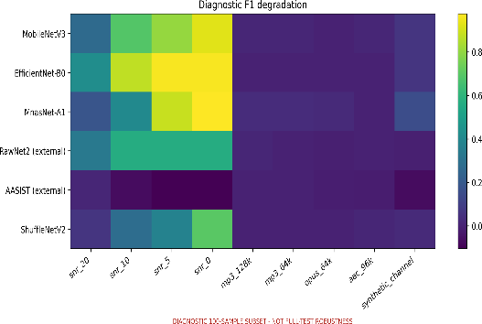(a) Nine-condition degradation
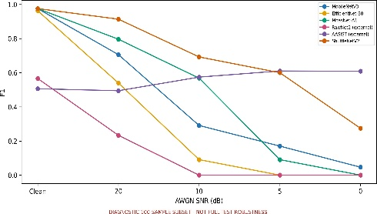 (b) AWGN F1 trajectory
Fig. 5. Fixed-subset diagnostic results on identical recordings; replay is simulated.
On the fixed subset, codec effects were small for the lightweight artifacts (mean ΔF1: 0.0000-0.0233). Under simulated replay, ShuffleNetV2 retained F1 = 0.9500 (ΔF1 = 0.0256), versus ΔF1 values of 0.0620, 0.0641, and 0.1489 for MobileNetV3, the EfficientNet-B0 warm-up checkpoint, and MnasNet-A1. Negative external-artifact deltas reflect score redistribution around weak baselines, not general robustness.
Aggregate failure-pattern analysis. On the fixed subset, low-SNR AWGN caused the largest losses (mean noise ΔF1: 0.3555-0.8053), while simulated replay affected MnasNet-A1 most and ShuffleNetV2 least. These condition-level patterns may reflect sensitivity to band limitation and delayed echoes but do not establish causality. Paired scores are unavailable, so sample-level prediction flips cannot be identified.
  - Computational Efficiency
On the single-thread desktop CPU (Table 6), MobileNetV3 had the lowest end-to-end latency and RTF; ShuffleNetV2 ranked second among local artifacts. AASIST combined the smallest file with the largest latency, whereas RawNet2 combined the most parameters with moderate latency. Size and parameter count did not predict runtime; RSS is whole-process memory.
Table 6. Float32 batch-one desktop-CPU efficiency on AMD Ryzen 9 8940HX (10 warm-ups, 50 timed runs). RSS is whole-process memory.
Artifact | Params | Size (MiB) | RSS (MiB) | Model ms | E2E ms | P95 ms | clips/s | RTF
MobileNetV3 | 1.31M | 5.64 | 554.6 | 30.07 | 43.81 | 52.12 | 22.83 | .0146
ShuffleNetV2 | 1.87M | 7.74 | 501.8 | 48.05 | 62.52 | 75.37 | 15.99 | .0208
MnasNet-A1 | 3.37M | 13.43 | 566.0 | 95.25 | 117.00 | 138.96 | 8.55 | .0390
EffNet-B0 warm-up | 4.78M | 18.96 | 651.2 | 168.36 | 175.85 | 196.11 | 5.69 | .0586
RawNet2 ext. | 17.62M | 67.65 | 249.5 | 95.10 | 96.54 | 102.62 | 10.36 | .0239
AASIST ext. | 0.30M | 1.61 | 442.5 | 359.61 | 362.91 | 398.45 | 2.76 | .0899
  - RQ3 Corrected Pareto Trade-offs
Figure 6 identifies MobileNetV3 and ShuffleNetV2 as non-dominated under the evaluated objectives. MobileNetV3 has the lowest RTF (0.0146); ShuffleNetV2 has the highest mean stressed F1 (0.8133) at RTF 0.0208 and dominates the other four artifacts under these objectives. The frontier is exploratory, not a generally optimal ranking, because it uses 100 stress recordings and one desktop host.
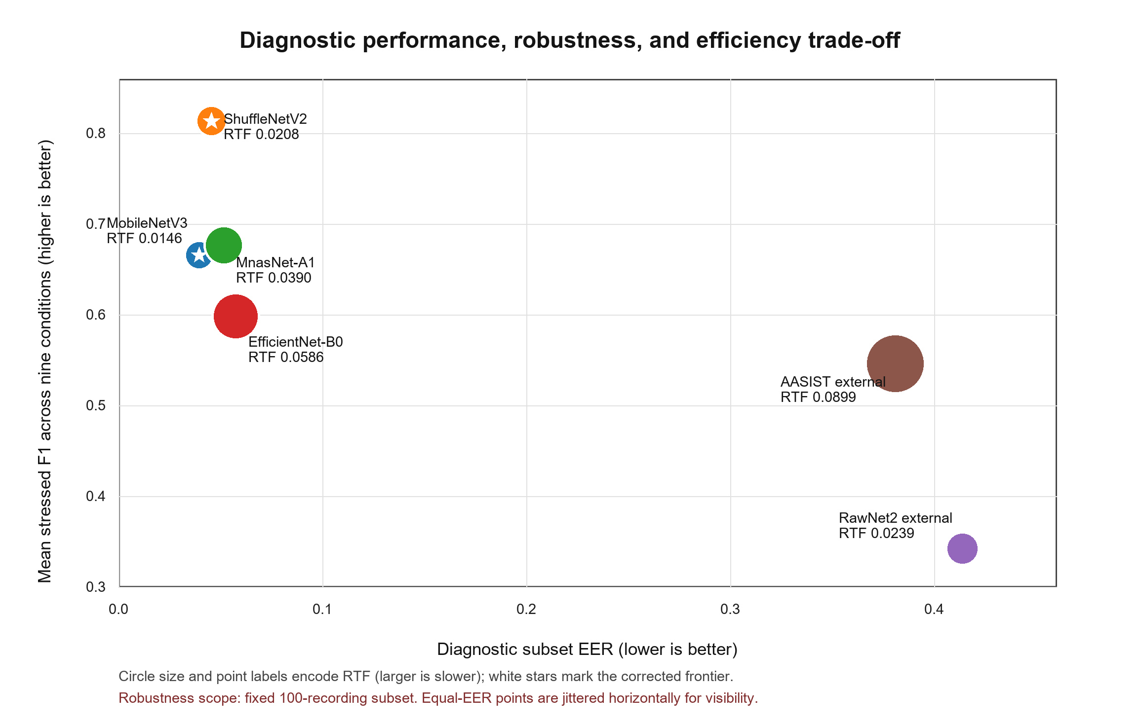
Fig. 6. Exploratory Pareto space under evaluated objectives. Stars mark non-dominated artifacts; EfficientNet-B0 is the available warm-up checkpoint.
- Conclusion
Evidence is limited by heterogeneous training and calibration, a fixed 100-recording diagnostic subset, simulated rather than physical replay, and one desktop CPU. The dataset cannot establish speaker, source, generator, parent-recording, or cross-dataset independence. No unseen-corpus, edge-device, streaming, or multi-seed evaluation was conducted; RSS is whole-process memory, EfficientNet-B0 is an available warm-up checkpoint, and paired scores for sample-level prediction-flip analysis are unavailable.
Recommendations remain artifact-, objective-, and platform-specific. Under the evaluated objectives, ShuffleNetV2 is the stronger predictive-performance candidate: it achieved the highest clean AUC, lowest clean EER, highest mean stressed F1, and remained non-dominated at RTF 0.0208. MobileNetV3 is the lower-latency candidate on the measured host. These findings do not identify a universally optimal model or rank architectures independently of their available artifacts.
LAVA provides an evidence-traceable comparison of six heterogeneous voice anti-spoofing artifacts. Under the evaluated conditions, MobileNetV3 and ShuffleNetV2 are non-dominated, while low-SNR noise is the main weakness observed on the fixed diagnostic subset. Future work should retain paired scores and test the full set, unseen corpora, physical replay, streaming, and target edge hardware [16], [17]. The current evidence supports deployment-oriented offline comparison, not general robustness or comprehensive deployment validation.

Acknowledgement
This research was supported by the University of Economics Ho Chi Minh City (UEH), Vietnam.

References
[1] J. Yi, C. Wang, J. Tao, X. Zhang, C. Y. Zhang, and Y. Zhao: Audio deepfake detection: A survey,arXiv preprint arXiv:2308.14970 14 (8),(2023).
[2] M. Li, Y. Ahmadiadli, and X.-P. Zhang: A Survey on Speech Deepfake Detection,ACM Computing Surveys 57 (7),1-38, (2024).
[3] M. Todisco et al.: ASVspoof 2019: Future Horizons in Spoofed and Fake Audio Detection. In: Interspeech 2019, pp. 1008-1012.
[4] J. Frank and L. Schönherr: WaveFake: A data set to facilitate audio deepfake detection,NeurIPS Datasets and Benchmarks (2021).
[5] T. Kinnunen et al.: t-DCF: A detection cost function for the tandem assessment of spoofing countermeasures and automatic speaker verification. In: Odyssey, pp. 312-319.
[6] J. Yamagishi et al.: ASVspoof 2021: Accelerating progress in spoofed and deepfake speech detection. In: ASVspoof 2021 Workshop, pp. 47-54.
[7] P. Veličković, A. Casanova, P. Lió, G. Cucurull, A. Romero, and Y. Bengio: Graph attention networks. In: International Conference on Learning Representations, pp.
[8] H. Tak, J. Patino, M. Todisco, A. Nautsch, N. Evans, and A. Larcher: End-to-end anti-spoofing with RawNet2. In: ICASSP, pp. 6369-6373.
[9] M. Ravanelli and Y. Bengio: Speaker recognition from raw waveform with SincNet. In: IEEE Spoken Language Technology Workshop, pp. 1021-1028.
[10] J.-w. Jung et al.: AASIST: Audio anti-spoofing using integrated spectro-temporal graph attention networks. In: ICASSP 2022, pp. 6367-6371.
[11] H. Tak, M. Todisco, X. Wang, J.-w. Jung, J. Yamagishi, and N. Evans: Automatic speaker verification spoofing and deepfake detection using wav2vec 2.0 and data augmentation. In: Odyssey, pp. 112-119.
[12] Z. Wu, R. K. Das, J. Yang, and H. Li: Light convolutional neural network with feature genuinization for detection of synthetic speech attacks. In: Interspeech, pp. 1101-1105.
[13] O. Pascu, A. Stan, D. Oneata, E. Oneata, and H. Cucu: Towards generalisable and calibrated audio deepfake detection with self-supervised representations. In: Interspeech, pp. 4828-4832.
[14] N. M. Müller, P. Czempin, F. Dieckmann, A. Froghyar, and K. Böttinger: Does audio deepfake detection generalize? In: Interspeech 2022, pp. 2783-2787.
[15] P. Kawa, M. Plata, and P. Syga: Attack agnostic dataset: Towards generalization and stabilization of audio deepfake detection. In: Interspeech, pp. 4023-4027.
[16] N. M. Müller, N. Evans, H. Tak, P. Sperl, and K. Böttinger: Harder or different? understanding generalization of audio deepfake detection. In: Interspeech, pp. 2705-2709.
[17] Y. Li et al.: Cross-domain audio deepfake detection: Dataset and analysis. In: EMNLP, pp. 4977-4983.
[18] A. Howard et al.: Searching for MobileNetV3. In: ICCV, pp. 1314-1324.
[19] N. Ma, X. Zhang, H.-T. Zheng, and J. Sun: ShuffleNet V2: Practical guidelines for efficient CNN architecture design. In: ECCV, pp. 116-131.
[20] M. Sandler, A. Howard, M. Zhu, A. Zhmoginov, and L.-C. Chen: MobileNetV2: Inverted residuals and linear bottlenecks. In: CVPR, pp. 4510-4520.
[21] X. Zhang, X. Zhou, M. Lin, and J. Sun: ShuffleNet: An extremely efficient convolutional neural network for mobile devices. In: CVPR, pp. 6848-6856.
[22] M. Tan et al.: MnasNet: Platform-aware neural architecture search for mobile. In: CVPR, pp. 2820-2828.
[23] M. Tan and Q. V. Le: EfficientNet: Rethinking model scaling for convolutional neural networks,ICML 97 6105-6114, (2019).
[24] B. McFee et al.: librosa: Audio and music signal analysis in Python. In: Proceedings of the 14th Python in Science Conference, pp. 18-25.

